All Classes | - Pencils and Pens  - Lined notebook paper
Social Studies | - One 1.5 inch three-ring binder  - 3 Dividers with pockets
Science | - One 3 subject notebook with built-in pocket folders
Math | - One 1.5 inch three-ring binder  (You can use your binder from last year or buy a new one)  - One set of dividers (5 count)
English Language Arts | - No supplies required
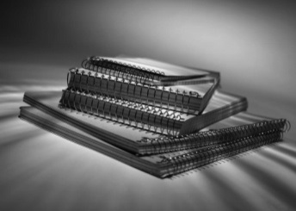

*Additional supplies may be required after school begins.

